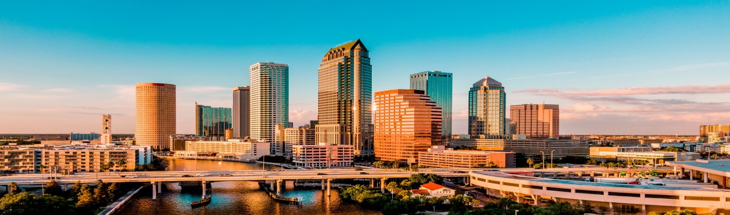
Professional Sales Training for the Material Supply Industry

Your registration for Carwie & Associates, “Level 1 Sales Training for the Material Supply Industry” in Tampa, Florida on November 16-18th 2026 is confirmed.

Some quick housekeeping items:
- All attendees should handle their own travel arrangements. We strongly encourage you to stay at the Marriott (505 Water Street) in downtown Tampa where we have negotiated a special rate.
- ROOM BLOCK RESERVATION METHOD:
  - https://book.passkey.com/go/BasicSalesTrainingNovember
  - Rooms must be booked by October 16th, 2026.
- A course outline can be seen at
- Please also note the following:
  - Carwie & Associates will host an optional reception on Monday night November 16th from 5:00-8:00 (Eastern Time Zone). Location and further details will be provided that morning.
  - The class will start at 8:30 AM on Monday November 16th and run until 2:00 PM on Wednesday November 18th. Travel from Tampa Marriott to the Tampa International Airport is 30-45 minutes depending on traffic. We strongly encourage you to book your flight after 4:00 PM on Wednesday.
  - We will be in Meeting Room 12; 3rd Floor unless otherwise notified.
  - Class pre-work assignments will be sent out approximately two weeks prior to starting class.
- The Water Street Marriott is ideally located in Downtown Tampa within walking distance of shopping, food, and entertainment options. A rental car is not recommended. Please see the following sites for additional details Viator Tampa Sites or https://www.thecrazytourist.com/15-best-things-tampa-florida/
- For sports fans, the Tampa Bay Lightning (Official Tampa Bay Lightning Website | NHL.com ) and Tampa Bay Bucs (Tampa Bay Buccaneers ) will be in season during this timeframe. Schedules will be released sometime during the summer.

See you in Tampa!

